**Department of IT, CSE(DS), CSE(IOT)**

**Team-12 Synopsis**

On

**Title: - Tour and Travel Booking System**

**Abstract: -**

A tour and travel booking system project is a software website designed to streamline the process of planning and booking trips and vacations. It enables travelers to search for destinations, compare prices, view itineraries, and make reservations for flights, accommodations, transportation, and activities all in one convenient platform. Additionally, it often includes features such as user profiles, payment processing, and real-time availability updates to ensure a seamless and hassle-free travel booking experience for both customers and travel provider.

**Introduction: -**

“Effortless Travel Planning: The Tour and Travel Booking System Project”. A tour and travel booking system project is a technology-driven solution designed to simplify and enhance the process of planning, booking, and managing travel experiences for individuals and groups. This project aims to provide a comprehensive platform that connects travelers with a wide range of travel services, including flights, accommodations, transportation, tours, and activities. The system offers numerous features such as real-time availability, price comparison, user reviews, secure payment processing, and personalized itinerary planning.

**Objective: -**

The objectives of a tour and travel booking system project should align with the goals of providing value to travelers and facilitating the efficient operation of the travel industry. Here are some key objectives that such a project should consider:

1. **Simplified Booking Process:** Make it easy for travelers to search, compare, and book a wide range of travel services, including flights, accommodations, transportation, tours, and activities, all within a single platform.
2. **Transparent Pricing:** Provide clear and accurate pricing information, including taxes, fees, and any additional charges, to ensure transparency and prevent unexpected costs for travelers.
3. **User Reviews and Ratings:** Allow users to share their experiences and provide ratings and reviews for accommodations, activities, and services, helping others make informed decisions.
4. **Secure Payment Processing:** Ensure the security of financial transactions by implementing robust payment processing systems and encryption technologies.
5. **Mobile Accessibility:** Create a responsive and user-friendly mobile app or website to cater to travelers who prefer to book and manage their trips on mobile devices.
6. **Customer Support:** Offer excellent customer support services, including 24/7 assistance, to address traveler inquiries, issues, and emergencies promptly.
7. **Safety and Security:** Provide information on travel safety, including emergency contact details and travel advisories, to ensure traveler well-being.
8. **Accessibility and Inclusivity:** Consider the needs of all travelers, including those with disabilities, by offering accessible travel options and information.
9. **Data Privacy and Security:** Ensure the privacy and security of traveler data by complying with data protection regulations and implementing strong security measures

**Tools and Technology Requirements:**

|  |  |  |
| --- | --- | --- |
| **Software Requirement** | **Front-End** | **Back-End** |
| Tools | VS code | PyCharm/Django MySQL  workbench 8.0 CE |
| Technology | HTML5 CSS3  JavaScript | Python  Django  Database |

**Functional Requirements:**

1. **User Registration and Authentication:**

* Users can create accounts with unique profiles.
* User authentication methods, including email, password, and possibly social media integration.

1. **Search and Booking Functionality:**

* Robust search engine for flights, accommodations, transportation, tours, and activities.
* Real-time availability checks and pricing.
* Booking and reservation features with confirmation emails.

1. **Personalization:**

* User profiles with preferences and travel history.
* Recommendation engine for personalized travel suggestions.
* Itinerary customization and planning tools.

1. **Payment Processing:**

* Secure payment gateways supporting various payment methods.
* Handling of currency conversions and multiple payment currencies.

1. **User Reviews and Ratings:**

* User-generated reviews and ratings for accommodations, activities, and services.
* Comment and feedback sections for travelers to share experiences.

1. **User Support and Communication:**

* 24/7 customer support channels (chat, email, phone).
* Automated notifications and alerts for booking updates and travel advisories.

1. **Mobile Compatibility:**

* Responsive design or dedicated mobile app for seamless mobile access.

1. **Safety and Emergency Information:**

* Travel safety tips and guidelines.
* Emergency contact information for local authorities and service providers.

1. **Accessibility Features:**

* Consideration for travelers with disabilities, including accessible accommodations and transportation options.

1. **Sustainability Initiatives:**

* Information on eco-friendly travel options and carbon offset programs.

**Non-Functional Requirements**:

1. **Performance:**

* **Response Time:** The system should respond to user actions within a defined timeframe, such as loading search results or processing bookings quickly.
* **Scalability:** The system should scale gracefully to handle increased user traffic and data volume during peak times without significant performance degradation.
* **Availability:** The platform should maintain high availability, with minimal downtime for maintenance or updates.

1. **Security:**

* **Data Security:** User data, including personal and payment information, must be securely encrypted and protected from unauthorized access or breaches.
* **Authentication and Authorization:** Implement secure user authentication and authorization mechanisms to prevent unauthorized access to sensitive features and data.
* **Compliance:** Ensure compliance with data protection regulations (e.g., GDPR, HIPAA) and industry security standards.

1. **Usability:**

* **User Interface Design:** The user interface should be intuitive, user-friendly, and accessible to people with disabilities (WCAG compliance).
* **Performance on Mobile Devices:** Ensure the platform is optimized for mobile devices, providing a seamless user experience.
* **User Satisfaction:** Measure and maintain high levels of user satisfaction through usability testing and feedback analysis.

1. **Reliability:**

* **Uptime:** The system should have high uptime, minimizing service interruptions and downtime for maintenance.
* **Fault Tolerance:** Implement mechanisms to handle system failures gracefully, ensuring minimal disruption to users.

1. **Interoperability:**

* **API Compatibility:** Ensure compatibility with third-party APIs and data formats for integration with airlines, hotels, and other service providers.
* **Cross-Browser Compatibility:** The platform should work consistently across various web browsers.

1. **Maintainability:**

* **Code Quality:** Maintain clean and well-documented code to facilitate future updates and maintenance.
* **Version Control:** Use version control systems to manage code changes and updates effectively.

1. **Load Testing:**

* Conduct load testing to determine the system's capacity and performance under different levels of user traffic and usage patterns.

1. **Cost Efficiency:**

* Optimize operational costs while delivering competitive pricing for travelers.

1. **Legal and Compliance:**

* Comply with legal requirements and regulations, including licensing, intellectual property rights, and terms of service.

1. **Environmental Responsibility:**

* Consider the environmental impact of system operations and promote sustainable travel options.

1. **Backup and Recovery:**

* Implement robust backup and recovery procedures to ensure data integrity and availability in case of data loss or system failures.

1. **Error Handling and Logging:**

* Implement effective error handling mechanisms and robust logging for debugging and analysis purposes.

**Area of Application:**

1. Travel Planning and Booking.
2. Personalized Itinerary Creation.
3. Price Comparison.
4. User Reviews and Ratings.
5. Community Building.
6. Accessibility.
7. Environmental Responsibility.
8. Safety and Emergency Information.
9. Mobile Convenience.
10. Integration with Partners.
11. Data Analysis and Reporting.
12. Continuous Improvement.
13. Support and Customer Service.
14. Multilingual Support.
15. Legal and Regulatory Compliance.
16. Cost Efficiency.

**Overview Of Project**

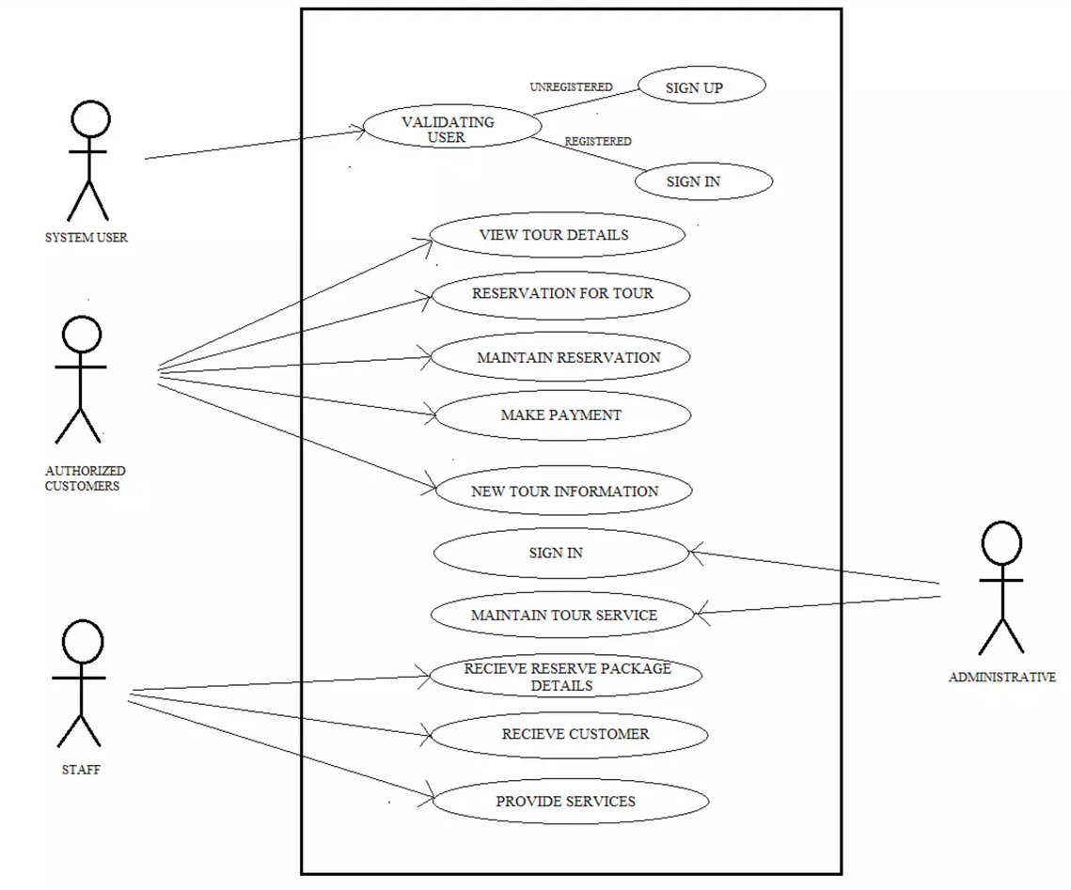

**Guided By: Group Members:**

Prof. Brajesh Chaturvedi Anuj Mishra: - 0827IT211015

Chirag Malviya: - 0827IT211031

Harsh Machiya: - 0827IT211040